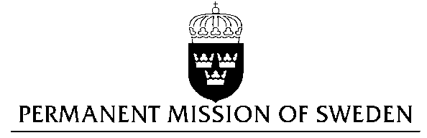
UN Human Rights Council

UPR 26th session

Statement by Sweden in the interactive dialogue on Iceland

Delivered by H.E. Ambassador Veronika Bard
Geneva, November 1, 2016 (speaking time 1 min 45 sec)

Mr President,

Sweden wishes to welcome the delegation of Iceland.

We appreciate that positive developments have taken place since the previous UPR. Iceland has recently adopted the Convention of the Rights of Persons with Disabilities, and has enhanced measures to deal with domestic violence.

Sweden recommends the Government of Iceland:

- To revise or make amendments to existing legislation, and to adopt all other necessary measures, in order to fight all forms of incitement and agitation to hatred and violence.

- To adopt a comprehensive national legislation to combat all forms of discrimination and to pass national legislation that lives up to the spirit of the CRPD.

- To conduct follow-up activities related to the implementation of national legislation and awareness campaigns aimed at reducing the number of cases of domestic violence.

In "Utvarp Saga" radio broadcasts and in social media, there have been incidences of unabashed racism without any official action taken. Incitement and agitation to hatred and violence, also directed at refugees, needs to be addressed by Icelandic authorities.

While we welcome Iceland’s ratification of the CRPD, we also note civil society criticism that proposed national legislation is not living up to the spirit of the Convention.

While important public awareness on domestic violence has been raised, only few cases of domestic violence have been prosecuted since the 2011 UPR. Sentences passed have been relatively lenient in nature.

I thank you Mr. President

